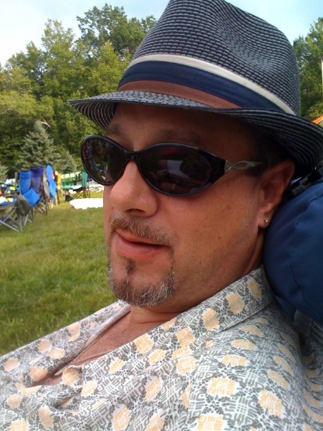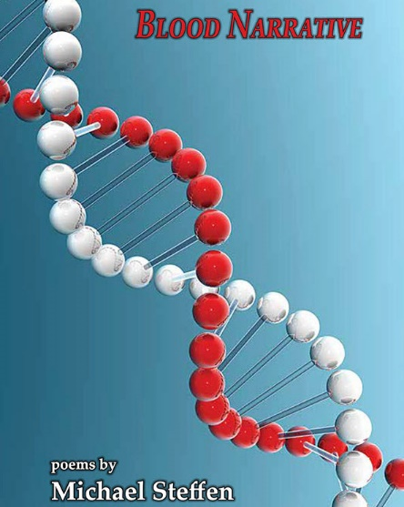

Award-winning poet MICHAEL STEFFEN will read from his recently-published collection, Blood Narrative (Main Street Rag Press, 2021), on (Insert date, time and venue location). Copies of the book will be available for sale, and a brief book signing will follow his reading.

Praise for Michael Steffen’s Poetry

These warm, generous, and lively poems speak to the narrative of body and spirit, of family, marriage, community and culture, as they come to terms with past and present losses. They do it best by living in the present, grateful for the whole of every moment—luscious, embarrassing, lonely, or loving, reveling in the sensual. Steffen’s capacity to surprise with sudden humor or beauty or truth infuses every poem, reminding us to live fully, because “somewhere offshore in the eye of apocalypse,/angels raise their trumpets—” as I raise mine, to this wonderful blood narrative.
- April Ossmann (author of Event Boundaries)

Steffen scrupulously avoids flamboyance, the sort of surface dazzle we find in poems that, like the stereotypical Chinese meal, are immediately appealing but leave us hungry instants later. His plain style approach allows his insights, as it were, to sneak up on us...until we discover ourselves (how did it happen?) in a world so full of pathos that we catch our breaths.
- Sydney Lea

About the Author

MICHAEL STEFFEN is the award-winning author of three previous poetry collections: No Good at Sea (Legible Press, 2002), which won the Legible Press Poetry Prize, Heart Murmur (Bordighera Press, 2009), which won the Bordighera Poetry Prize, appearing as a bilingual edition in both Italian and English, and Bad Behavior (Brick Road Poetry Press, 2012), which won the Brick Road Poetry Prize. While a resident of Pennsylvania, Michael was granted a 2002 Fellowship from the Pennsylvania Council on the Arts and has had poems appear in literary publications such as Poetry, Potomac Review, Chiron Review, Poet Lore and the American Journal of Poetry. He has read and lectured widely, been a mentor in the PEN Prison Writing Program and curated the now-defunct Riverside Reading Series in Easton, PA, hosting many outstanding poets such as Meg Kearney, Daisy Fried, Craig Czury, Lee Upton, Len Roberts and Gerald Stern. Michael is a graduate of the MFA in Creative Writing Program at Vermont College and currently lives in Buffalo, New York.

Visit www.mnsteffen.com for further biographical information and instructions on how to purchase books.

